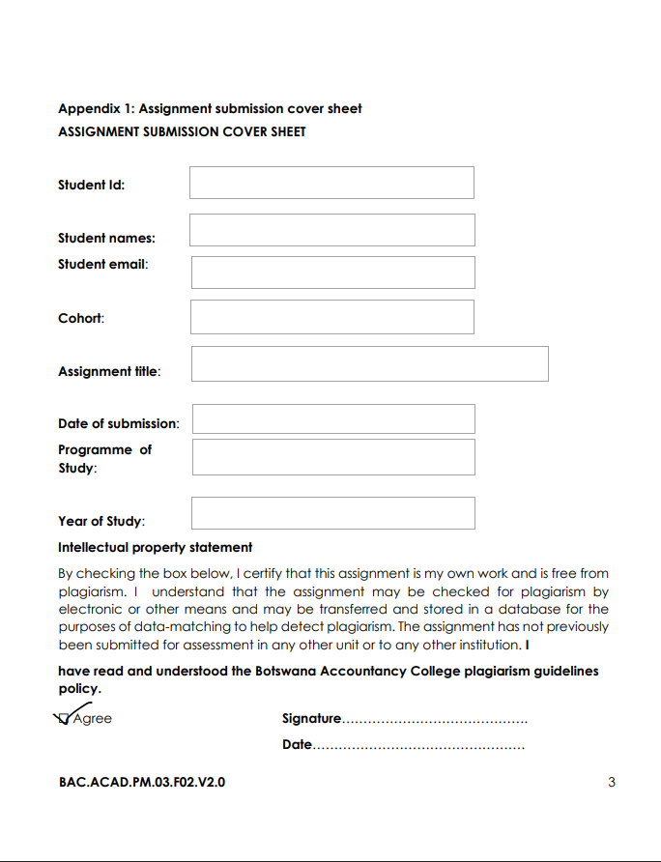
KAMOGELO EUNICE MORERWA
Cse24-098
k.morerwa
19 Sep. 25
2025
CSE
19 Sep. 25
The banking system
2025
cse24-098@thuto.bac.ac.bw

THE BANKING SYSTEM
This document outlines the functional and non-functional requirements for the proposed Banking System as elicited from client interview.
THE FUNCTIONAL REQUIREMENTS
On user authentication:
- The system shall allow the user to log in using a unique username and password.
- The system shall display an error message upon login attempts(for example, “invalid username or password”).
On customer management:
- The system shall allow a customer to open multiple accounts, the account types include the Savings Account, Investment Account and Cheque Account.
- The system shall allow a customer to select their desired account type when opening an account with a bank.
On transaction processing:
- The system shall allow an authenticated user to deposit funds into any of their accounts.
- The system shall allow an authenticated user to withdraw funds from their accounts, except from the Savings Account. Withdrawal from the Savings Account shall be disabled.
- The system Shall Validate all transactions the system shall reject any deposit less than BWP500.
- The system shall immediately display an on screen error message for any failed transaction (e.g “ Error: Minimum deposit for an investment account is BMW P500” or “Error: withdrawals are not permitted from savings account”).
On balance and history inquiry:
- The system shall allow an authenticated user to view the current balance of any of their account.
- The system shall generate and display transaction history for any selected account
- The transaction history shall include for each entry; Date, Transaction Type(e.g Deposit, Withdrawl), Amount, Debit or Credit, and the Account Balance after the transaction.
Interest calculation:
- The system shall automatically calculate and apply interest to accounts monthly
- The system shall apply a monthly interest rate of 2.5%(0.025) to individual Savings Accounts.
- The system shall apply a monthly interest rate of 7.5%(0.075) to Company Savings Accounts.
- The system shall apply a monthly interest rate of 5% to Investment Accounts
THE NON-FUNCTIONAL REQUIREMENTS
Security:
- The system shall require the user authentication(login) to access all the functions and data.
Usablity:
- The system shall provide clear, user-friendly error messages that guide the user to correct the action (e.g., stating the minimum deposit amount).
- The user interface shall be intuitive and require minimal training for a standard banking customer to use.
Performance:
- The system shall respond to user inputs (clicks, form submissions) within 10 seconds under normal load.
- Balance and transaction history queries shall complete and display results within 10 seconds.
Accuracy:
- All financial calculations (balances, interest) shall be 100% accurate.
- The transaction history log shall be an accurate and immutable record of all successful and attempted transactions.

Appendix: Interview Record
Interviewer: Kamogelo Eunice Morerwa
Client: Mr Kentsanao Baseki
Date: 18 September 25
Purpose: To elicit core functional and quality requirements for the new banking system.
Transcript summary:
Interviewer: "What are the essential functions a customer should be able to perform?"
Client: "The customer must be able to open an account of their choice, log in, deposit funds, withdraw funds, view their balance, and view their transaction history. Withdrawal should not be possible from a savings account."
Interviewer: "Can a customer have more than one account?"
Client: "Yes, the customer must be able to open multiple accounts."
Interviewer: "Could you describe the interest application process?"
Client: "Interest applies monthly. For savings accounts, the rate will be 0.025 for an individual and 0.075 for a company. This should be fully automated by the system."
Interviewer: "What should happen if a transaction fails?"
Client: "The system must display transaction failures. For the GUI, the message should display on the screen. For example, keying in any value less than 500 for an investment account deposit should give an immediate error."
Interviewer: Should the system handle incorrect login attempts, like maybe an account can log out after three tries?”Client: "We need a login, but we don't need to dwell much on advanced features like tracking failed login attempts for now. Basic authentication is sufficient."
Interviewer: "What details are needed in the transaction history?"
Client: "It must include the day, the type of transaction, the amount showing if it's a debit or credit, and the balance after that transaction."
Interviewer: "Is transferring funds between accounts a required feature?"
Client: "No, transferring between accounts is not necessary for this version."

STRUCTURAL UML MODELING
- THE USE CASE DIAGRAM
- 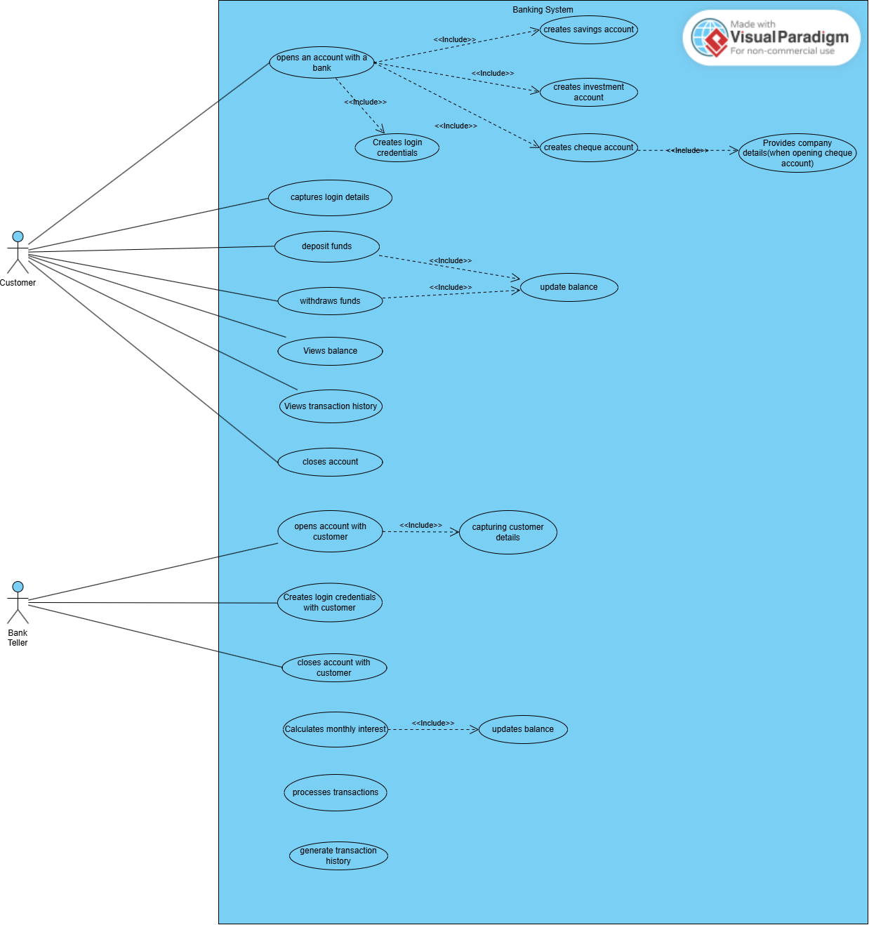

- CLASS DIAGRAM

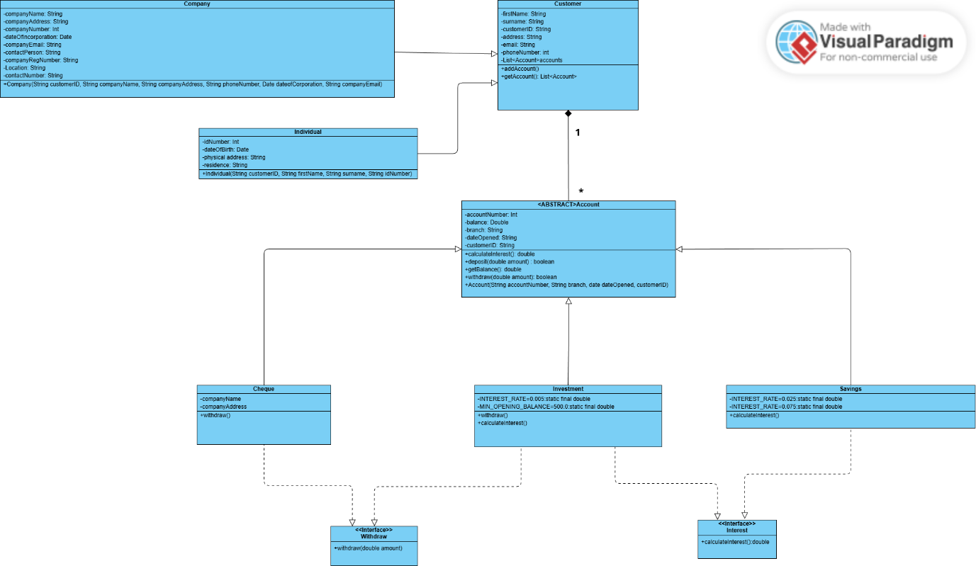

BEHAVIOURAL UML MODELLING
- i. SEQUENCE DIAGRAM FOR OPEN ACCOUNT
- 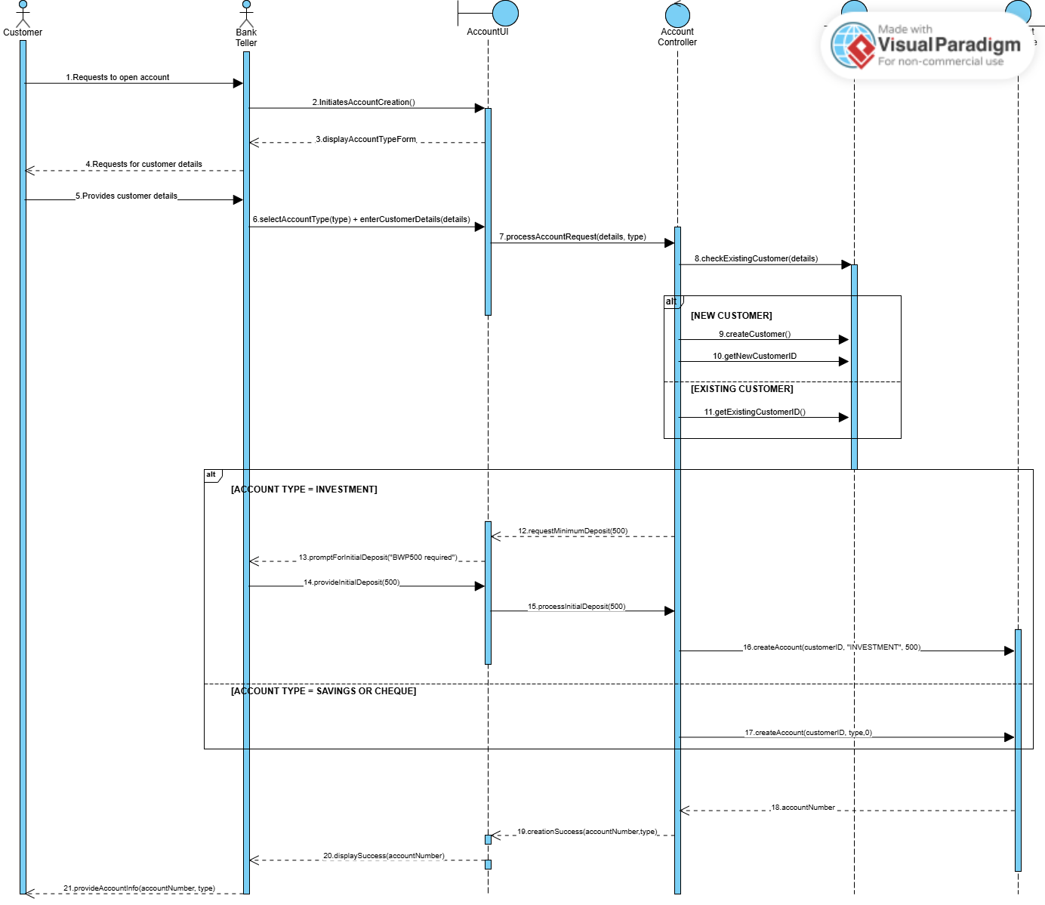
Account Database
Customer Database

ii. SEQUENCE DIAGRAM FOR DEPOSIT FUNDS
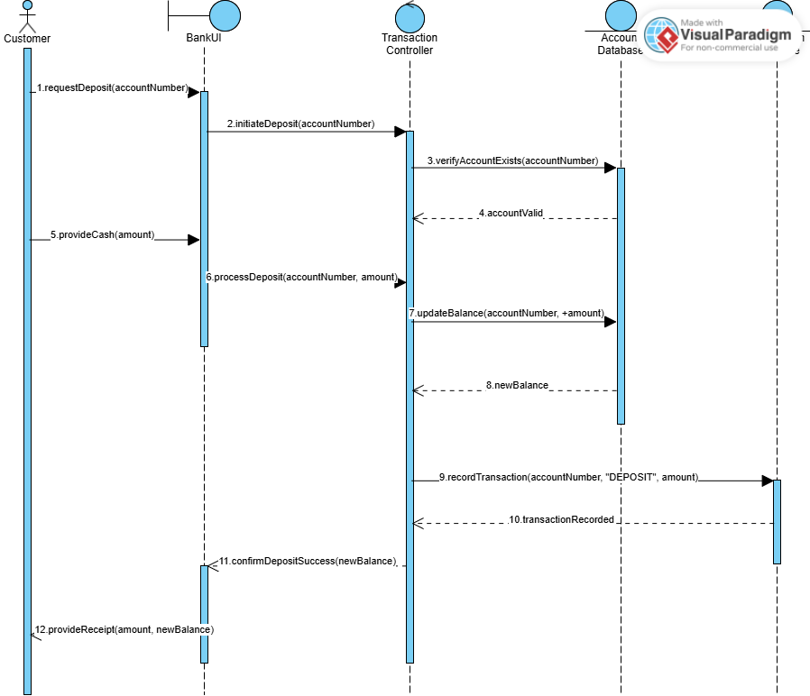
Transaction Database

- STATE DIAGRAM
- 